LITTLE BRICKHILL 7th July 6pm-8pm
We will be outside the village hall or inside (weather dependent)
Information on ASB ’Know Your Rights’ and careers
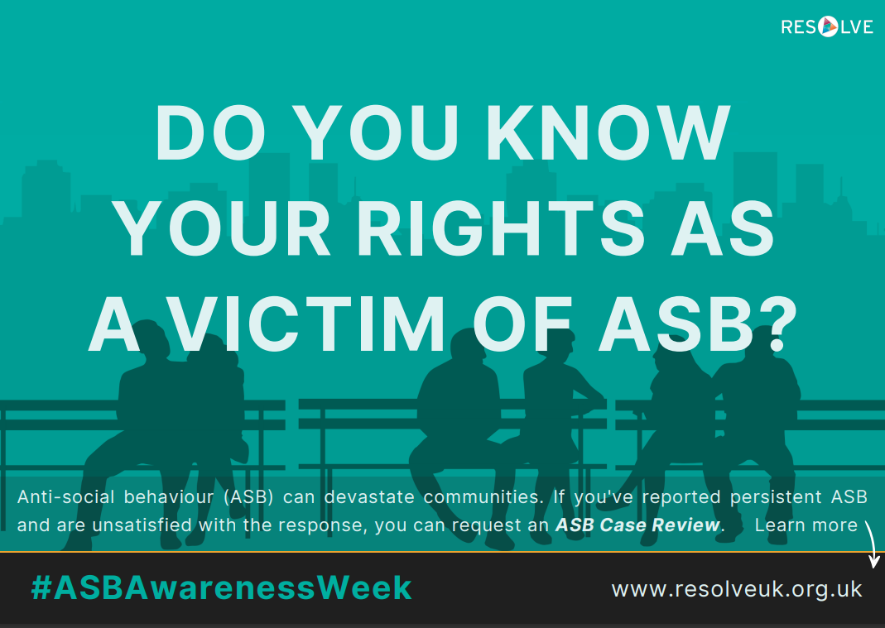
We will also be conducting patrols as part of ASB Awareness Week 2023

